**ML Study Design - Google Street View Blurring System**

Objective:



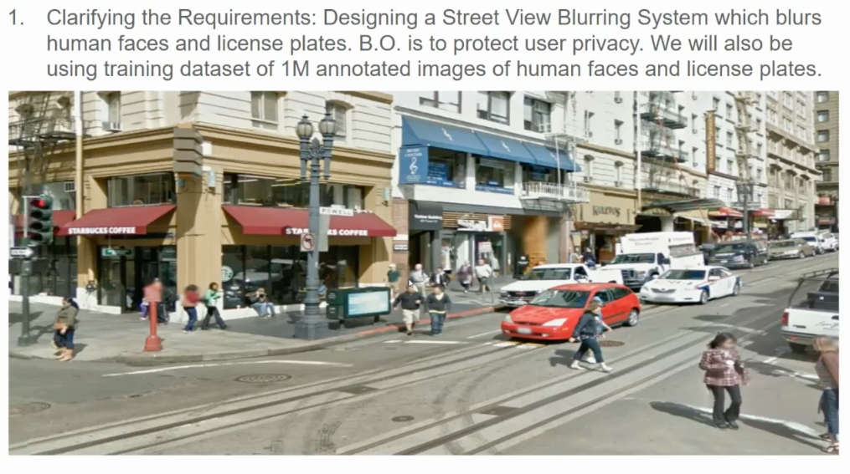

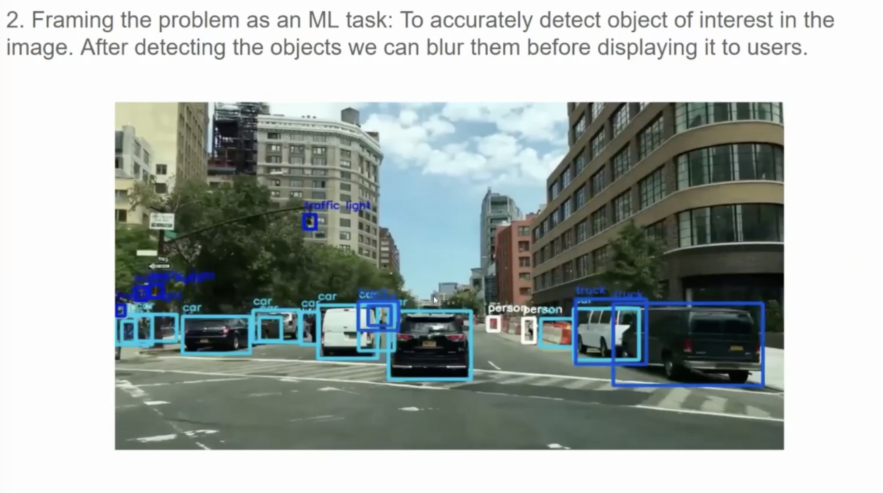

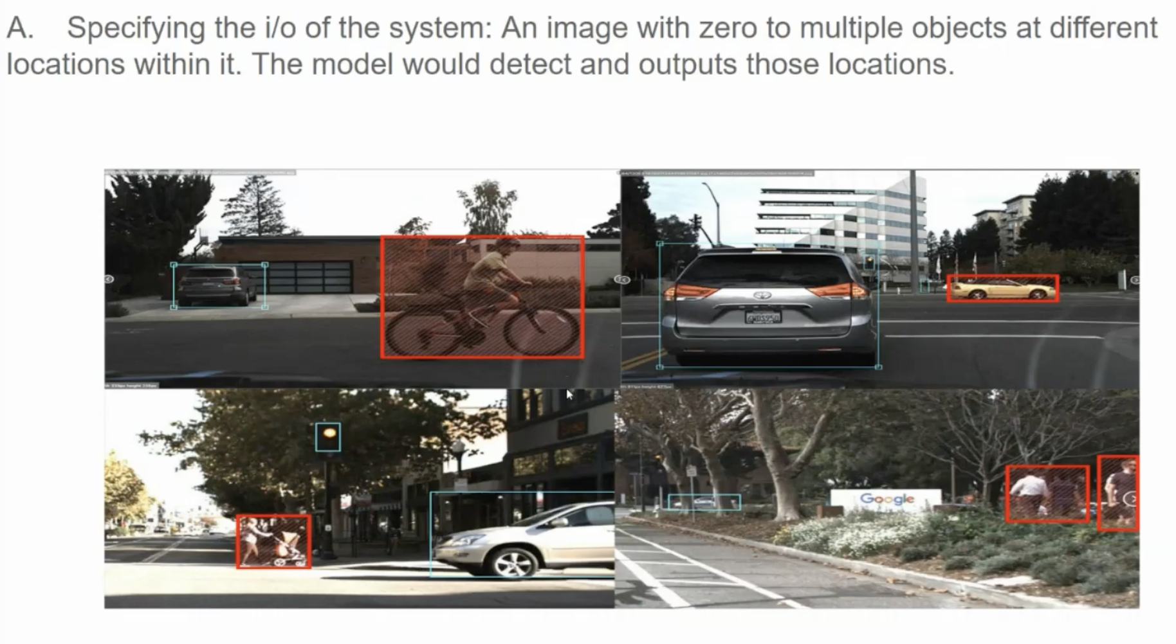

In a given image, first objects are located and then the bounding boxes are created around the object.

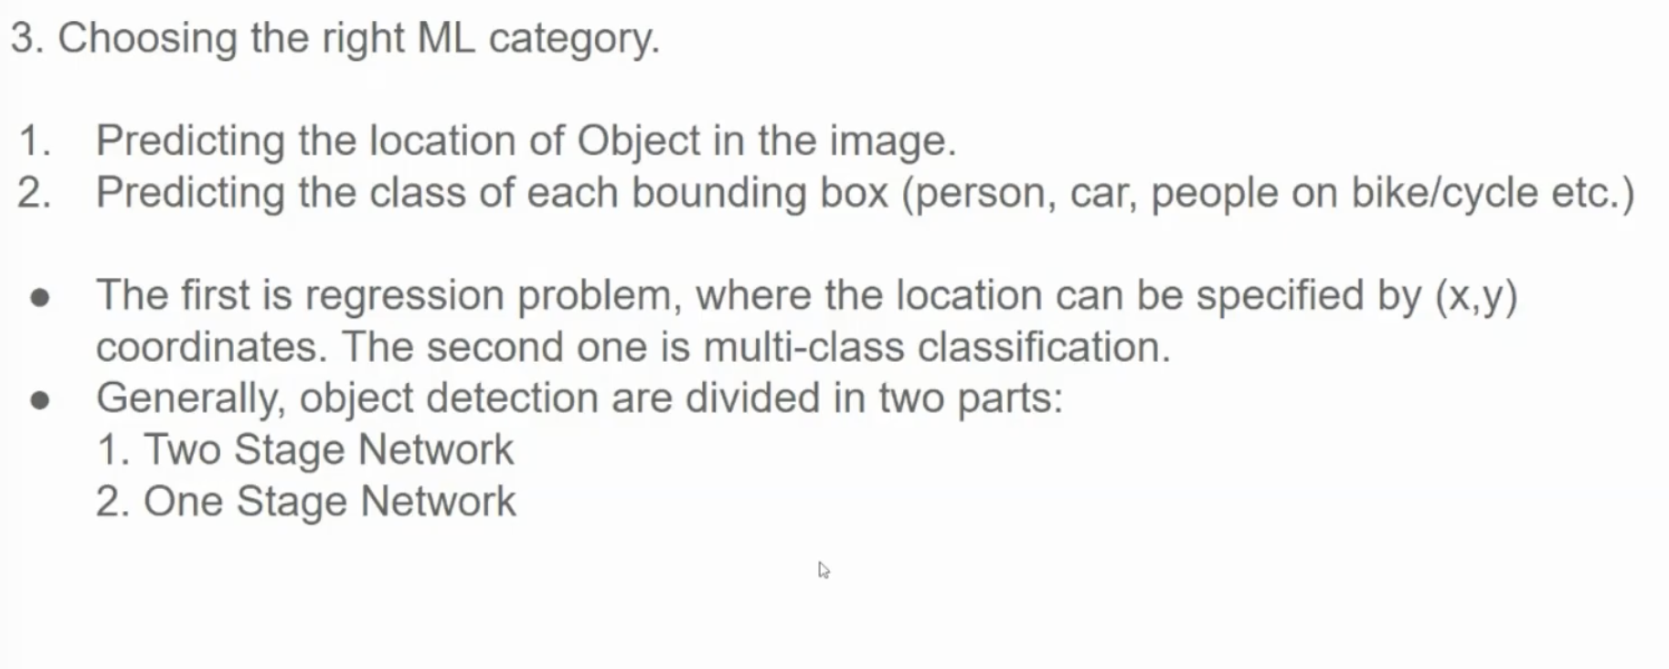

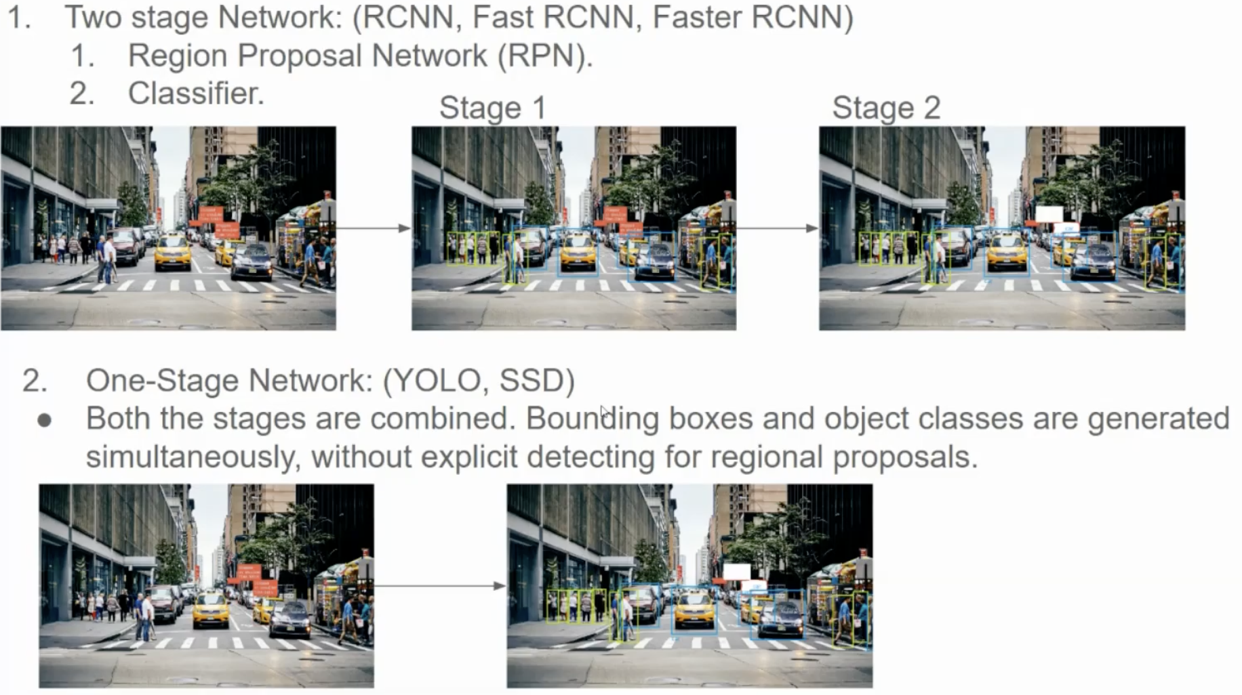

**What is an RPN?**

A **Region Proposal Network (RPN)** is a critical component in object detection systems like Faster R-CNN. Its role is to generate **proposals**—regions in an image that are likely to contain objects—quickly and accurately.

**How Does It Work?**

1. **Feature Extraction**:
   * The RPN uses a **feature map** produced by a convolutional neural network (CNN) as input.
   * This feature map captures essential details about the image, such as edges, textures, and patterns.
2. **Anchor Boxes**:
   * At each position in the feature map, RPN places predefined **anchor boxes**—rectangles of various sizes and aspect ratios.
   * These boxes act as potential candidates for object regions.
   * **Example**: For a 10x10 feature map with 3 scales and 3 aspect ratios, RPN creates 10×10×9=900anchor boxes.
3. **Objectness and Bounding Box Refinement**:
   * For each anchor box, RPN predicts:
     + **Objectness Score**: How likely it is that the box contains an object (vs. background).
     + **Bounding Box Adjustment**: Precise shifts to the box’s position, width, and height to better match the object.
   * **Example**: An anchor box at (5, 5) with size 32x32 pixels might be refined to:
     + Objectness score: 0.9 (high confidence)
     + Adjusted box: Center (5.2, 5.1), Size 30x40 pixels.
4. **Proposal Generation**:
   * **Filtering**: Anchor boxes with low objectness scores are discarded.
   * **Refinement**: The remaining boxes are adjusted using the bounding box predictions. An anchor box might be at (x=100, y=150) with width 50 and height 30. The RPN might predict dx=2, dy=-1, dw=4, dh=-2. The refined box would then be at (x=102, y=149) with width 54 and height 28.
   * **Non-Maximum Suppression (NMS)**: Overlapping proposals are merged, leaving only the highest-quality ones.

**How it works:**

* + - Sort the remaining proposals by their objectness scores in descending order.
    - Select the proposal with the highest score.
    - Compare this proposal with all other remaining proposals.
    - If the Intersection over Union (IoU) between the selected proposal and any other proposal is greater than a certain threshold (e.g., 0.7), discard the other proposal (because it's considered redundant).
    - Repeat steps 2-4 until all proposals have been considered.
    - **Intersection over Union (IoU):** IoU is the ratio of the area of overlap between two bounding boxes to the area of their union. A high IoU means the boxes overlap significantly.
    - **Effect:** NMS ensures that each object is represented by only one (or a few) high-quality proposal(s), further reducing the number of proposals passed to the next stage of the object detection pipeline.

**Why is RPN Important?**

* RPN enables **end-to-end training**, allowing the model to jointly optimize region proposals and object classification.
* It’s computationally efficient, as it operates directly on the feature map without requiring separate sliding window or region extraction steps.

YOLO

YOLO (You Only Look Once) is a single-stage object detection system that performs detection directly on a grid overlaid on the input image. Here's a concise breakdown:

1. **Grid Division:** The input image is divided into an S x S grid (e.g., 7x7).
2. **Cell Predictions:** Each grid cell is responsible for predicting:
   * **B bounding boxes:** Each bounding box has:
     + (x, y): Center coordinates relative to the cell.
     + (w, h): Width and height relative to the image.
     + Confidence score: Probability of an object being in the box *and* the box being accurate.
   * **C class probabilities:** A probability distribution over the C object classes.
3. **Encoding:** These predictions are encoded into a tensor of size S x S x [B * 5 + C], where 5 represents the 4 bounding box coordinates + the confidence score.
4. **Non-Max Suppression (NMS):** Because multiple cells might detect the same object, NMS is used to filter out redundant bounding boxes, keeping only the ones with the highest confidence scores and sufficient IoU (Intersection over Union).
5. **Loss Function:** YOLO uses a loss function that combines:
   * Bounding box regression loss (how well the predicted boxes match the ground truth).
   * Confidence loss (how accurate the objectness predictions are).
   * Classification loss (how accurate the class predictions are).

**Key Differences from Two-Stage Detectors:**

* **No Region Proposals:** YOLO directly predicts bounding boxes and class probabilities without a separate region proposal step. This is what makes it much faster.
* **Grid-Based Detection:** Detection happens at the grid cell level. Each cell is responsible for predicting objects whose centers fall within it.

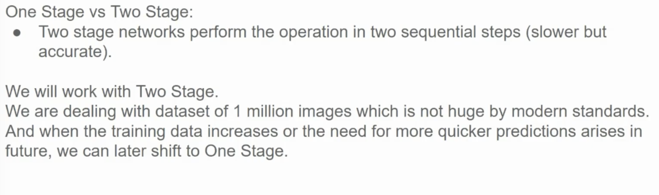

Some other models

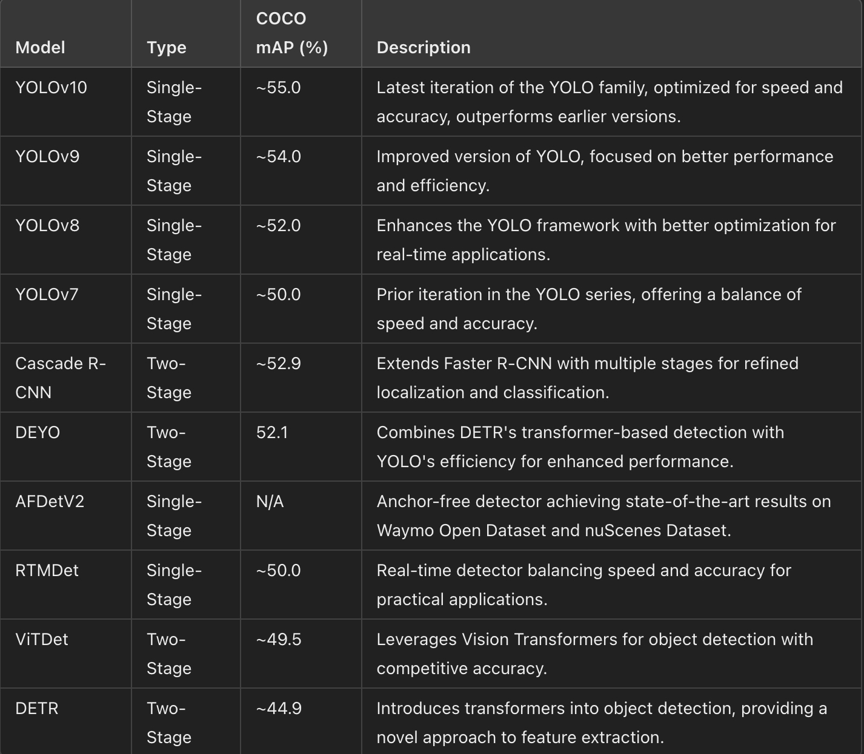

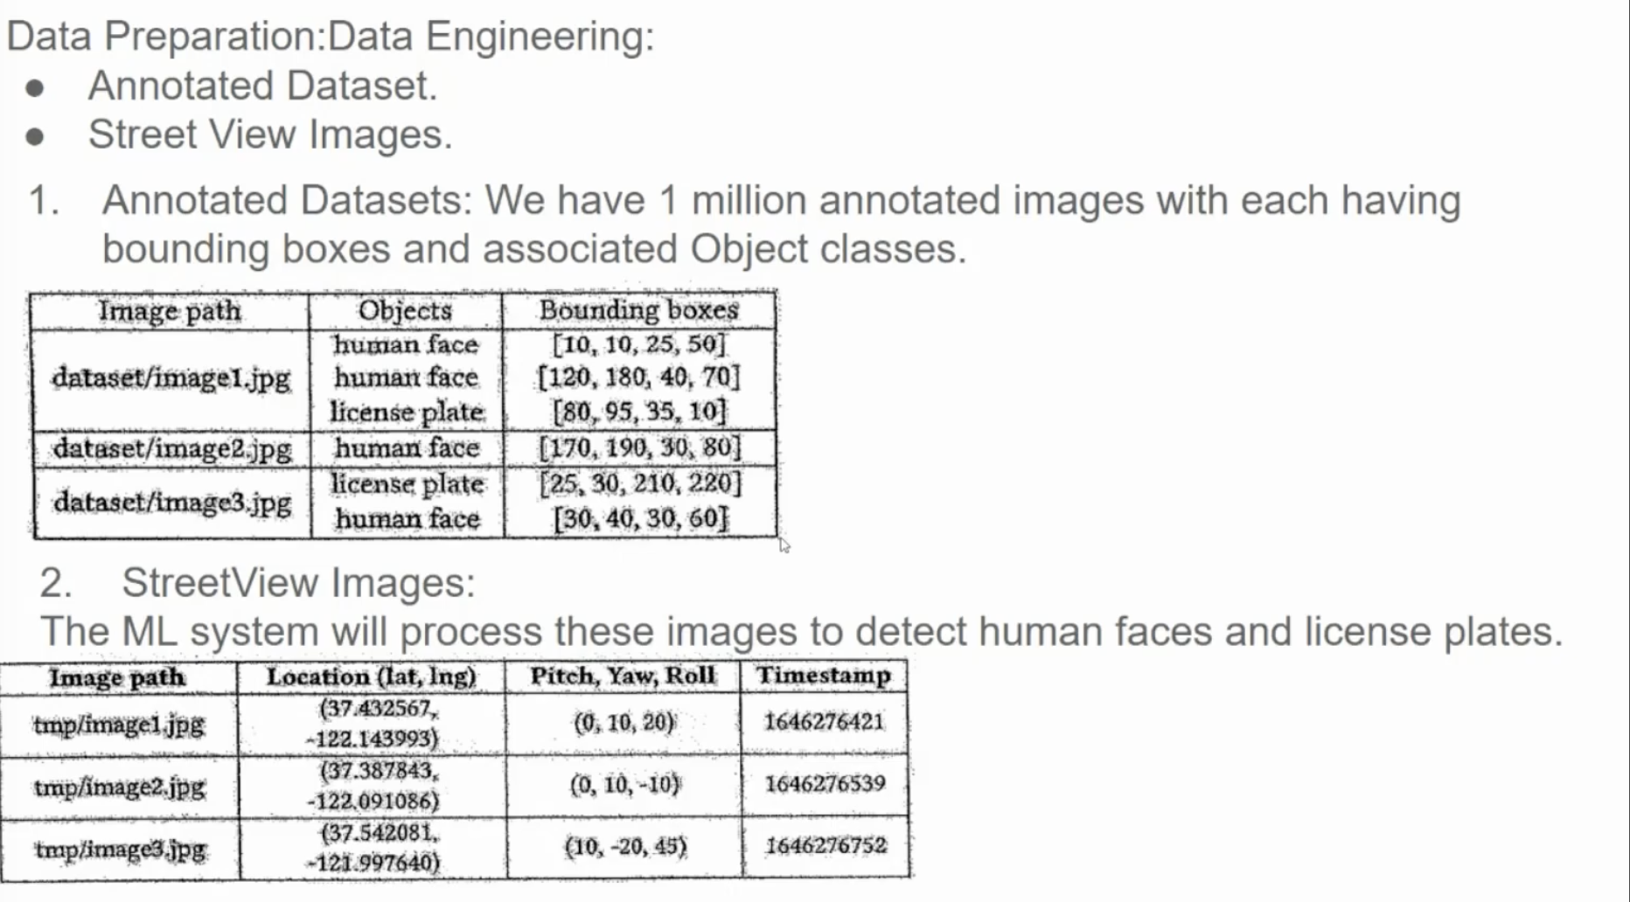

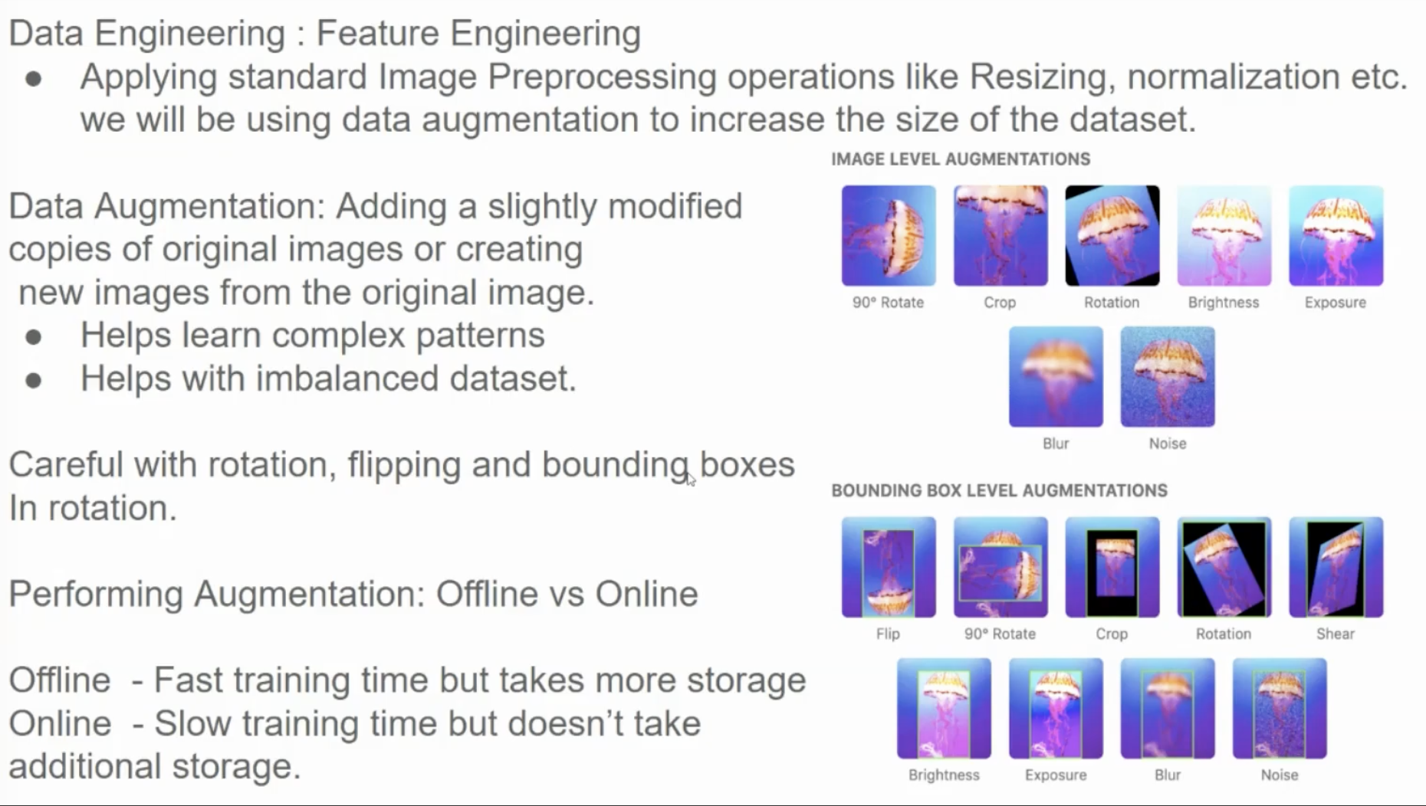

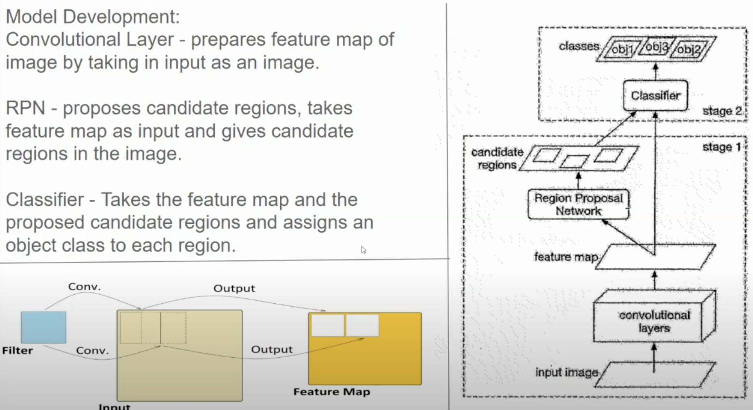

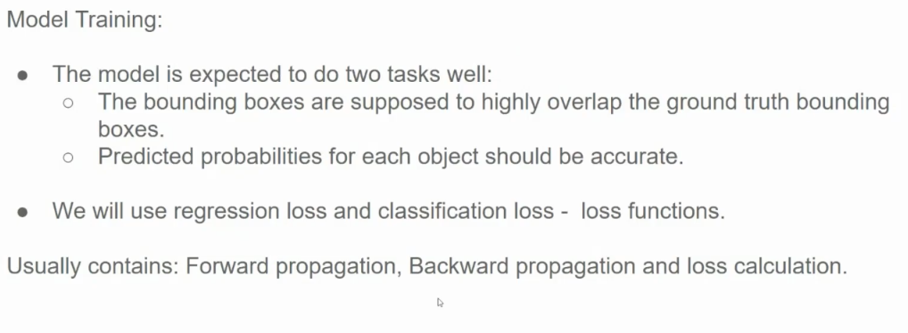

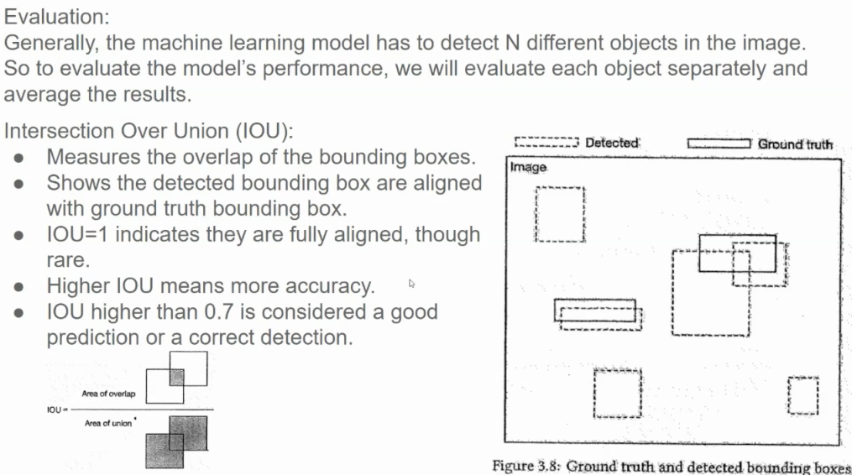

**Example of per-class evaluation and mAP for a two-stage detector:**

Two classes ("cat", "dog") and two images are used for a simplified example.

* **Image 1:** 2 cats, 1 dog (ground truth). Predictions: 3 cat predictions (2 correct), 1 correct dog prediction.
* **Image 2:** 1 cat, 2 dogs (ground truth). Predictions: 1 correct cat prediction, 3 dog predictions (2 correct).

Using precision and recall (simplified, AP is usually from a curve):

* **Cat:** Image 1: P=0.67, R=1.0. Image 2: P=1.0, R=1.0. AP (simplified average): 0.835
* **Dog:** Image 1: P=1.0, R=1.0. Image 2: P=0.67, R=1.0. AP (simplified average): 0.835

mAP (average of per-class APs): (0.835 + 0.835) / 2 = 0.835

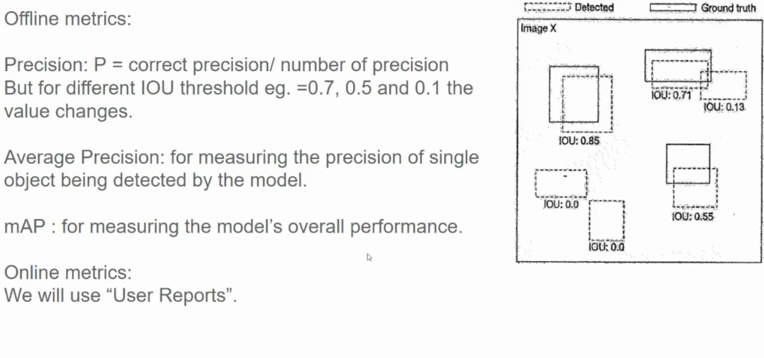

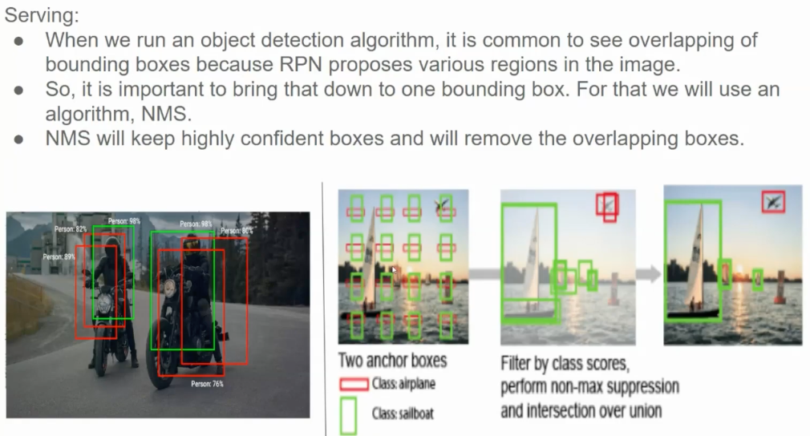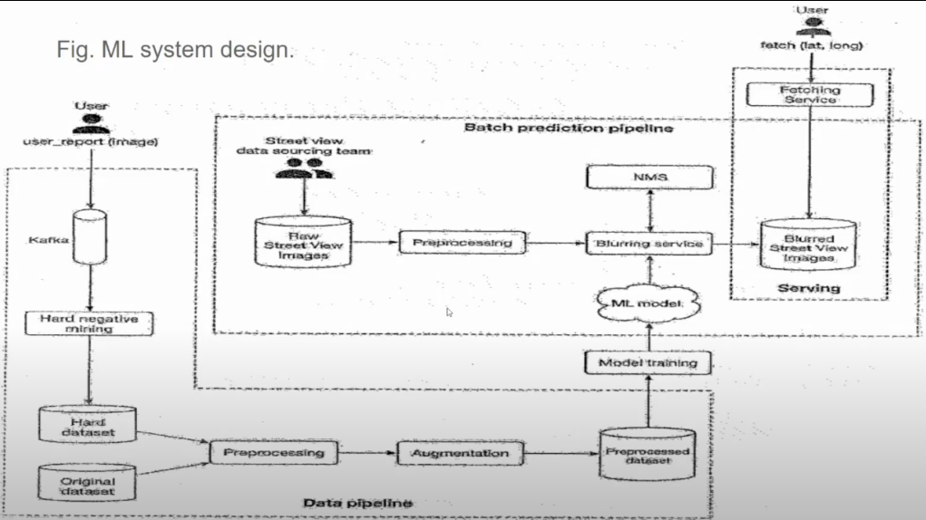

The "Hard negative mining" component likely processes the initial training results to identify and select the most challenging false positives. These hard negatives are then used to augment the dataset for subsequent training iterations.

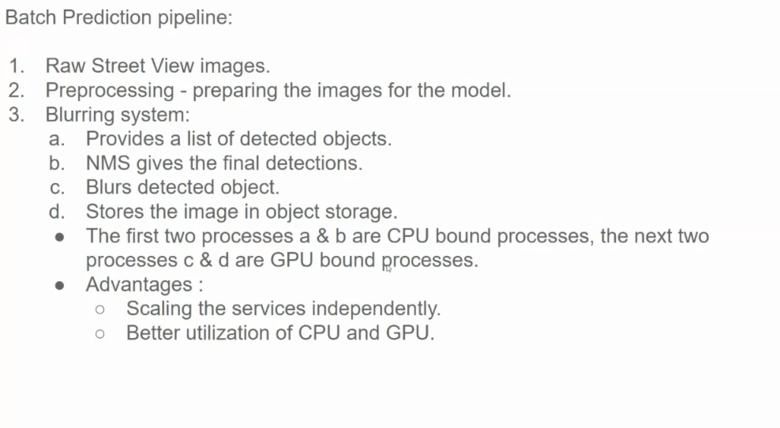

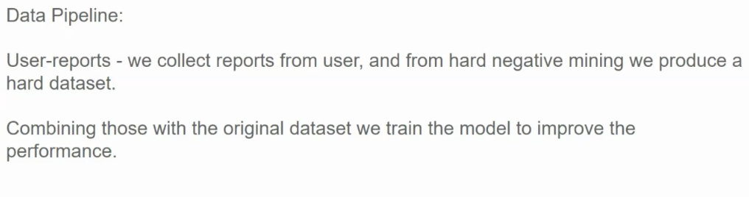

Questions:

**Dr. Mamta's Question:**

●**Question:** Is there a way to understand the data and what kind of data augmentation can be applied without misunderstanding the data, especially when there is limited data and human intervention is undesirable?

●**Answer:** Jit acknowledged that data augmentation needs careful consideration. He explained that in the Street View example, using completely upside-down images would be inappropriate because they wouldn't occur in reality. He suggested focusing on realistic scenarios and data that would likely be encountered. Prasa and Dr. Mamta highlighted the importance of human intervention, particularly with limited datasets, to ensure appropriate augmentation and avoid inaccurate results. They emphasized the need for a "human in the middle" to evaluate and select suitable data for training to prevent false positives and negatives.

**Pry's Questions:**

●**Question:** How do you determine what to blur when trying to protect privacy, considering that blurring the whole face might be excessive?

●**Answer:** Jit did not directly address this question. However, Prasa and he agreed that blurring specific features like eyes and noses could suffice for de-identification while reducing processing demands.

●**Question:** How does the system differentiate overlapping objects, like a person in a vehicle, when applying different blurring to each?

●**Answer:** Jit didn't explicitly answer this. However, his presentation explained that the system uses bounding boxes and assigns object classes (person, car, etc.) to each detected region. This suggests that the model can distinguish and apply different blurring to overlapping objects based on their classifications.

Single-stage object detection models differentiate overlapping objects by:

1. **Bounding Box Regression**: Predicting separate bounding boxes for each object in the overlap region.
2. **Object Classification**: Assigning class probabilities (e.g., person, vehicle) to each predicted bounding box.
3. **Non-Maximum Suppression (NMS)**: Ensuring that overlapping boxes with lower confidence scores are suppressed, retaining the most confident predictions for distinct objects.
4. **Feature Maps**: Utilizing spatial and contextual features from the image to accurately separate and classify objects even in overlapping scenarios.

●**Question:** Since Google Street View is a live view, how does the system process real-time images and select frames for blurring?

●**Answer:** Jit clarified that Google captures panoramic images and stitches them together to create a route view. This process suggests the blurring happens on static images rather than live video streams. Pry and Prasa discussed the complexities of handling live video streams, proposing frame rate reduction and selective image processing as potential solutions.

**Prasa's Questions and Suggestions:**

●**Question/Suggestion:** Can we discuss various object detection models, including YOLO (You Only Look Once) and SSD (Single Shot Detection), and compare their strengths and weaknesses?

●**Answer/Response:** Jit briefly mentioned YOLO and SSD as examples of one-stage object detection networks5. Prasa emphasized the need to delve deeper into these models, including RCNN variations (Fast RCNN and Faster RCNN), and compare their architectures and performance characteristics.

●**Question/Suggestion:** Can we discuss the differences between commercial models, open-source models, and models described in research papers?

●**Answer/Response:** This question wasn't answered directly. However, Prasa suggested incorporating this comparison into future discussions to provide a broader perspective on the landscape of object detection models.

●**Question/Suggestion:** Should we discuss ImageNet and COCO image databases, which are widely used in the computer vision community?

●**Answer/Response:** This question was not addressed. However, Prasa's suggestion highlights the value of exploring publicly available datasets to understand how models are trained and evaluated.

●**Question/Suggestion:** Can we discuss the mathematical aspects of image processing, focusing on techniques like data pre-processing and augmentation, and the libraries that support them?

●**Answer/Response:** While the presentation touched upon pre-processing techniques like resizing and normalization, it didn't delve into the mathematical details9. Prasa advocated exploring the mathematical underpinnings of these techniques and discussing libraries that facilitate their implementation. He proposed exploring topics such as wavelet transforms, contour analysis, and relevant libraries to enhance the understanding of image processing techniques.